JAPANESE CLASS （September - December） Nikko City International Association
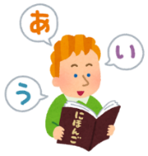
The Nikko City International Association organizes a free Japanese classroom! Volunteer teachers will teach you at your level.

TIME： 19:00～20:30
WHAT TO BRING: Writing utensil, notebook
LOCATION： Nikko Civic Activities Support Center 1F Houtoku Hall （304-1 Imaichi, Nikko）
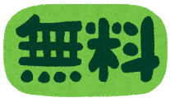
DATE：（All held on Thursdays）
SEPT： 11th, 15th OCT: 9th, 23rd
NOV：6th, 27th DEC： 11th, 18th
NOTE: We will also hold a Japanese class in Fujihara; if you are interested in participating, please contact us!

※If you will be participating for the first time, please contact us!
☎TEL: 21-5112 (WEEKDAYS 9:00～17:00)
Nikko City Hall ・ Community Safety Division （2F）

WATCH OUT FOR HEAT STROKE!
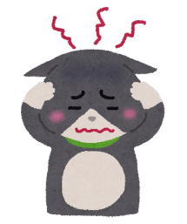
During hot summers like these, it is important to stay out of the heat and hydrated – even if you aren’t thirsty!
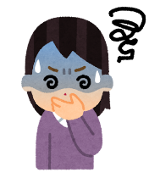
SYMPTOMS
Headaches, dizziness or lightheadedness, nausea, loss of consciousness, sore muscles, cramps, etc. are all common signs of heat stroke!
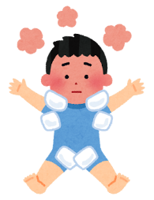
WHAT TO DO?
- Move to a cooler location
- Cool the body (especially the neck, underarms, and groin area)
- Be sure to consume fluids and salts
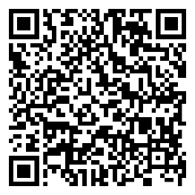
If your symptoms do not resolve, please go to a hospital!
Ministry of Health, Labor, and Welfare (MHLW)
https://tinyurl.com/5a8e22xz
※Please scan the QR code for details! (Scroll down for multilingual versions!)
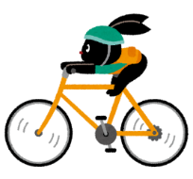
BICYCLE SAFETY
In Japan, the rules for bikes are similar to those for cars. In order to ride safely, please note the below!
BICYCLE SAFETY RULES
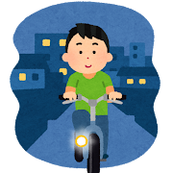
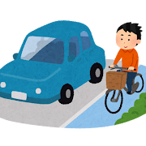
- Ride on the LEFT side of the road. (If riding on a sidewalk, give pedestrians the right-of-way.)
- Stop at crosswalks before crossing
- Turn on your headlight at night
- Do not drink alcohol then ride your bike
- Wear a helmet （this is a “duty of effort” so if you are unable to wear a helmet, you will not be penalized）
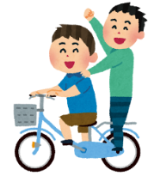
- Do not wear earbuds/headphones, look at your phone, or hold an umbrella while your ride
- Only person should ride at a time
- Do not ride more than 2 bicycles next to each other
IF A RULE IS BROKEN…
If you break a rule, you may be warned by a police officer. If you fail to follow the law, you may also have to pay a fine. If the fine is not paid, you may have to go to court.
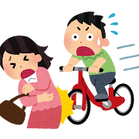
INSURANCE
In Tochigi, you must be enrolled in bicycle insurance. Accidents can be very expensive, and insurance will make those costs easier to bear.
ANTI-THEFT REGISTRATION (bouhan touroku)
If you purchase or get a bike from someone else, make sure that it is no longer registered with its previous owner. Visit the police station for guidance if necessary.
Daily Life Orientation Videos Immigration Services Agency (ISA)
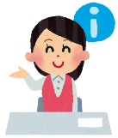

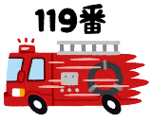
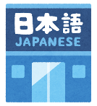
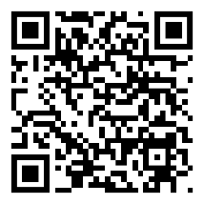
Japan’s Immigration Services Agency (ISA) has prepared videos to help foreign nationals learn about living and working in Japan! There are videos about traffic rules, healthcare, natural disasters, immigration procedures, learning Japanese, and more! For details, please see the ISA’s website.
https://www.moj.go.jp/isa/content/001422843.pdf
Available languages: Japanese, English, Chinese (simplified AND traditional), Korean, Vietnamese, Nepali, Indonesian, Filipino, Thai, Portuguese, Spanish, Khmer (Cambodian), Burmese, Mongolian, Ukrainian, Russian

